Worksheet 9.1

Inventions and innovations
Student: Class:
1. Use a dictionary to look up the words ‘invention’ and ‘innovation’. These words don’t mean
quite the same thing, do they? Describe the difference between these terms in your own words.

2. What is the difference between ‘science’ and ‘technology’?

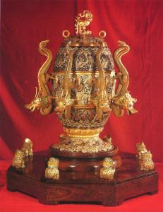
3. The picture at right shows what is believed to be the earliest known earthquake detector or ‘seismometer’. It was invented by the Chinese scientist Zhang Heng almost 2000 years ago, and was able to detect earthquakes 854 kilometres away.
Suggest how the seismometer may have worked.

Photo: Public domain

4. List what you consider to be the five most important inventions in the past 100 years.

CHAPTER 9: Science quests
Worksheet 9.1

Page 2

Clocks
In the past, church bells or a town crier helped communities to know the time. Clocks were invented and placed on public buildings in western Europe from the end of the thirteenth century. By the seventeenth century, smaller home versions were available. These clocks were not very accurate because there was no way of controlling the rate at which they worked.
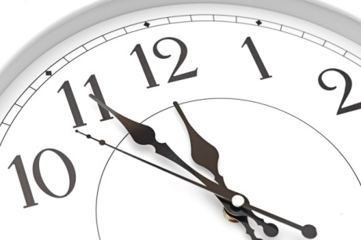
It was Galileo (1564–1642) who first noticed that a pendulum swinging backward and forward kept equal time on each swing. Galileo made this discovery during a church sermon as he watched a swaying chandelier and used his pulse to time its swings. The Dutch scientist Christiaan Huygens (1629–1695) applied Galileo’s discovery to control the rate of clocks, inventing the pendulum clock in 1656.
The discovery of the pendulum as a method of recording accurate time solved the problem of how to measure longitude. It became possible to explore the world. Trade between nations began and Europeans started to colonise distant lands.
What would your everyday life be like if man-made clocks had never been invented? Write a paragraph below describing what would change in your typical day if that were true.
Photo: Vadim Yerofeyev / 123RF

